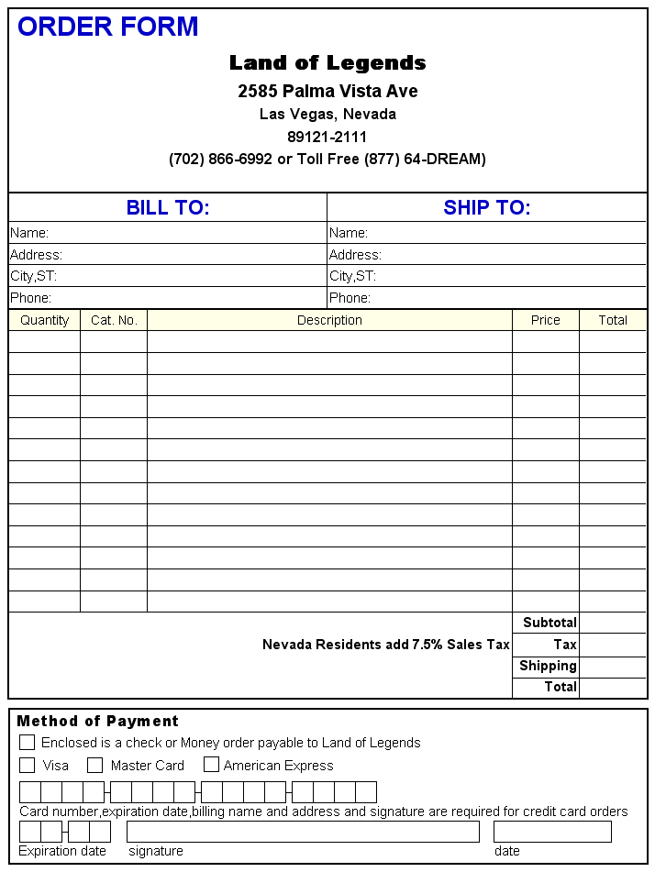

Shipping & Handling Rates
(United States)
Amount of Purchase Basic Shipping
Up to 10.00 $5.00
10.01 to 100.00 $10.00
100.01 to 200.00 $15.00
200.01 to 300.00 $20.00
300.01 and up $25.00
*Rates subject to change depending on carrier
We use UPS and USPS where ever possible

Basic Shipping and Handling Rates are for each address to which we send merchandise.
Please allow 7-10 working days for in stock items to be delivered.

Special Shipping Rates;
Same day or next day delivery... Call for current rates
Canada/Mexico; add 50% of US Rates
Overseas; Double the US Rate

